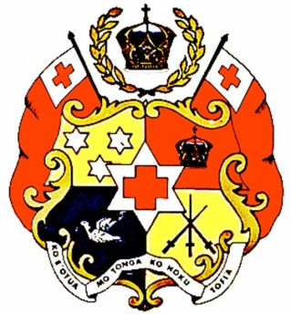

Tonga Country Statement at the 2017 Global Platform for Disaster Risk Reduction, Cancun, Mexico, 25 May, 2017

Delivered by Mr. Leveni Aho
Director- National Emergency Management Office
Government of the Kingdom of Tonga

Excellencies,
Distinguished delegates
Ladies and Gentlemen

- At the outset, allow me to first express the Government of the Kingdom of Tonga’s utmost gratitude to the Government and people of Mexico for their most sincere and warm hospitality accorded to our delegation upon our arrival in to your beautiful country.

- Tonga is ranked second most vulnerable country in the World to tropical cyclones, earthquakes, tsunami, storm surges, flooding and drought which attaches great significance to our commitment to the Sendai Framework. We declare that disaster risk reduction is one of the leading priorities in our national development framework and will continue in to the next decade and beyond.

- Disasters increasingly threaten the very existence of Small Island Developing States such as Tonga, whose vulnerabilities to natural hazards are rapidly increasing and our capacity and ability to build resilience is affected by an economy that is highly depended on outside influences.

- The Government of Tonga is committed to building resilience to disasters through dedicated national and international efforts towards mainstreaming of disaster resilience into both Government and Community development plans (CDPs), and ensuring their implementation. Moreover, Government adopted the United Nation Cluster System for coordination disaster risk reduction and recovery activities in February 2015 and has been the main coordination model used since.

- Due to limited local funding capacity to address disaster risks, we call for the further support of international multilateral funds, regional organisations and development partners in enhancing our efforts through direct financial support to implement our national plans and project proposals with a focus on resilient development.

- We are commited to further strengthening dialogue and partnerships with our partners for the enhancement of actions, support and synergies in the areas of technology, capacity building and the requisite financing for implementation. The Government of the Kingdom of Tonga calls for rapid where possible, direct access to funding from both bilateral and multilateral funds.

- Tonga recognises the importance of building a robust Multi Hazard Early Warning System in building disaster resilience and further call for support in implementing impact forecasting and use of scientifically proven traditional knowledge together with smart technologies to get timely and understood warning messages out to remote communities to save lives and reduce losses.

- We are also working toward downscaling regional and global geospatial and space-based technologies, and related services so that we can adapt scientific and technological information to suit our most vulnerable regardless of status, location or gender.

- We place great emphasis on the importance of cooperation and implementation of the 2030 Agenda for Sustainable Development and the Sustainable Development Goals (SDGs), the Sendai Framework and the Paris Agreement. We commit to fully implement the sustainable development targets and mainstream those goals into our national plans to strengthen our resilience to the effects of natural hazards.

- In closing, I urge us all to work together and build on what we have achieved here in Mexico and continue to share good practices and resources to sustainably meet all our global and national disaster risk reduction targets.

Malo ‘aupito, Thank you

