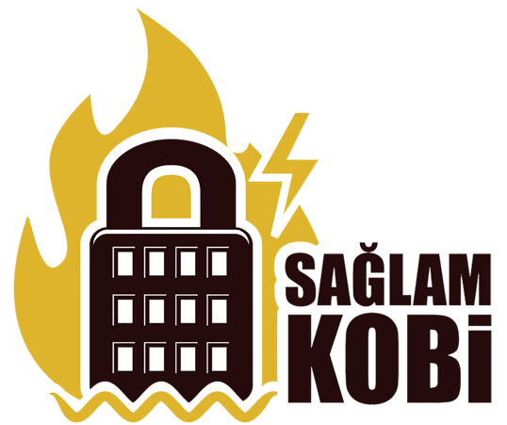
After the devastating 2011 Van Earthquake in Turkey, a disaster preparedness initiative entitled “Business Disaster Resiliency Program for Turkey” (or “Saglam KOBI” in Turkish) was developed by the World Economic Forum, Corporate Social Responsibility Association of Turkey (CSR Turkey), the U.S. Chamber of Commerce Foundation, the UPS Foundation and UPS Turkey. The project aims to engage the private and public sector and civil society organizations to work together to identify best practices to enhance the resiliency of small and medium sized enterprises (SMEs) in Turkey. The project which has been operating since 2013 is being managed by IDEMA.
Through this collective effort, Saglam KOBI aspires to provide SMEs with a suite of resources designed to assist businesses of all sizes. Businesses that only have a few minutes can access simple tips to prepare themselves and their staff for disasters, through reading the unique content on www.saglamkobi.com website, disaster preparedness checklist, and 20 tips for preparedness. Saglam KOBI also offers a toolkit available for free for businesses to create their own emergency action plans.

Saglam KOBI was publicly launched on September 17, 2013. In the first year, 12 training sessions were conducted with 246 businesses trained and more than 5,000 unique visitors to the website. Saglam KOBI has 19 partners who form the Advisory Board to advise the program and support where appropriate. Now in its sixth year, Saglam KOBI has scaled its impact through not only continuing the direct trainings for SMEs but now also offers Train the Trainer sessions to educate more trainers to help SMEs prepare an emergency action plan. To date, more than 3000 SMEs have gone through the training program and 25 trainings and train the trainer sessions have been conducted in 65 cities.

