Intergovernmental Authority on Development
Autorité Intergouvernementale pour le Développement

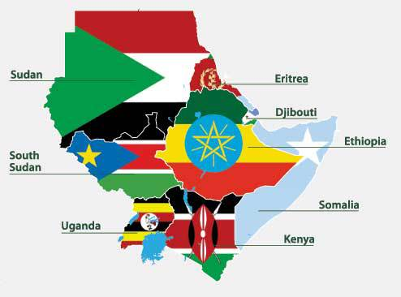

STATEMENT

OF THE SECRETARIAT OF

THE INTER-GOVERNMENTAL AUTHORITY ON DEVELOPMENT (IGAD)

AT

THE WORLD GLOBAL PLATFORM 2019 ON DISASTER RISK REDUCTION

13 -17 MAY 2019

GENEVA, SWITZERLAND
Chairperson
Your Excellencies,
Distinguished Delegates,
Ladies and Gentlemen,
IGAD Secretariat wishes to congratulate the UN-DRR team under the able leadership of Ms Mami Mizutori and her team on the work well done in the preparation of this Global Platform on 2019. .
IGAD allies itself with the Statement made by the Africa Union Commission on behalf of Africa.
The Intergovernmental Authority on Development (IGAD) is a regional organization comprised of 8 Member States. The IGAD region has been facing recurrent disasters impacting negatively on millions of its population resulting from various natural and human-made hazards such as, among the most common, drought, flood, landslides, epidemics & pandemic of diseases and notably conflict. Disaster Risk Management has become thus one of IGAD’s priority strategic core programme areas and has been implemented since 2004.

Ladies and Gentlemen,

The IGAD region has been endeavouring to make a conscious paradigm-shift from the traditional reactive humanitarian based disaster management approach to a disaster risk management approach that emphasizes preventive measures and the incorporation of disasters management in national and regional development programmes. IGAD member states have taken a decisive move in this direction. All member states have reviewed their respective policies and institutionalized DRM in their respective government structures.

IGAD Member States have established mechanisms: such as DRR National Platforms. Platforms that bring together governmental and nongovernmental actors; and regional level Ministerial and Technical Advisory Committee (DRM-TAC) mechanisms have been established and are operating actively. However, the legislative part of national policies and strategies in most Member States are yet to be realized.

The challenges faced, among others, include the practical sustenance of political commitment across the member states and transforming the commitment to operational level by integrating DRR in national development plans and allocation of resources/budgets instead of paying dearly in disaster response. IGAD sees as necessary for the sustainability of the DRR programs the need of the region policymakers to internalize the economic benefits of mainstreaming DRM far outweigh the costs of disaster response.

Chairperson, Distinguished Delegates
In order to build safer communities, future actions should be contextual⎯in view of current climate variability and the long-term effects of climate change⎯to consider addressing the strengthening of regional and national hydro-meteorological services and DRM institutions as well as other relevant stakeholders in order to sustain what has been accomplished so far under the HFA- and now being implemented under the Sendai Framework. In view of the current trends in climate change and variability in the context of IGAD region which has more areas under arid and semi-arid estimated at 70%, the effects will be more visible and felt unless we act with urgency.

On Sendai Framework on DRR;

IGAD has taken concrete steps in advancing the agenda in the following priority areas which are in line with the outcome of the Africa Program of Action and the Sendai Framework 2015 – 2030.

- Revised strategies to align with the Sendai Framework and Africa Programme of Action;
- A Framework for Integration of DRR/DRM and Climate Change Adaptation
- Development of a regional strategy for mainstreaming DRM and CCA into school curricula;
- Involving the media at the regional and national level to enhance DRM agenda at all levels;
- Increase and sustain investment in DRR/DRM, especially at the community level with emphasis on building resilience through investing in climate-smart agriculture in semi-arid areas in most vulnerable area;
- Endeavored to enhance knowledge management and capacity building in understanding disaster risk at regional and national levels by carrying out a series of training and awareness raising activities;
- Strengthen core capacities of the IGAD Climate Prediction and Applications Centre (ICPAC) and National Meteorological and Hydrological Services to provide early warning that meet needs of DRM;
- Reinforce Regional Climate Outlook Forums every 3 to 4 months towards impact based early warning system for early action for strengthening preparedness by involving all relevant sectors of the Member States;

In Conclusion

IGAD is committed to continuing working and partnering with UN-DRR and other development partners in achieving the DRR agenda. IGAD is committed to the realization of the Sendai Framework and associates itself with the 2030 Agenda for Sustainable Development, the Addis Ababa Action Agenda, and the Paris Agreement on climate change.

I thank you for your attention

