Relevant pictures: Mr. Toshizo Ido, Governor of Hyogo Prefecture, as Campaign Champion

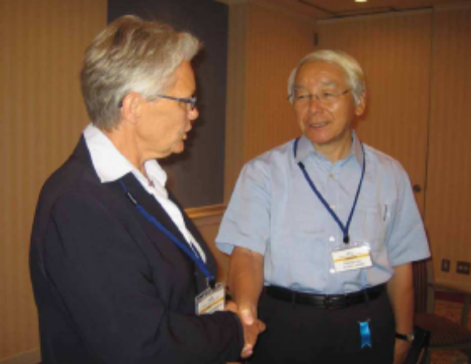
Mr. Ido was recognized for his efforts and achievements in advancing disaster risk reduction (DRR) in Hyogo Prefecture, and in sharing expertise and lessons learned from the 1995 Great Hanshin-Awaji Earthquake with the world. (at the SRSG’s courtesy call in Kobe, Japan on 15 September 2010)

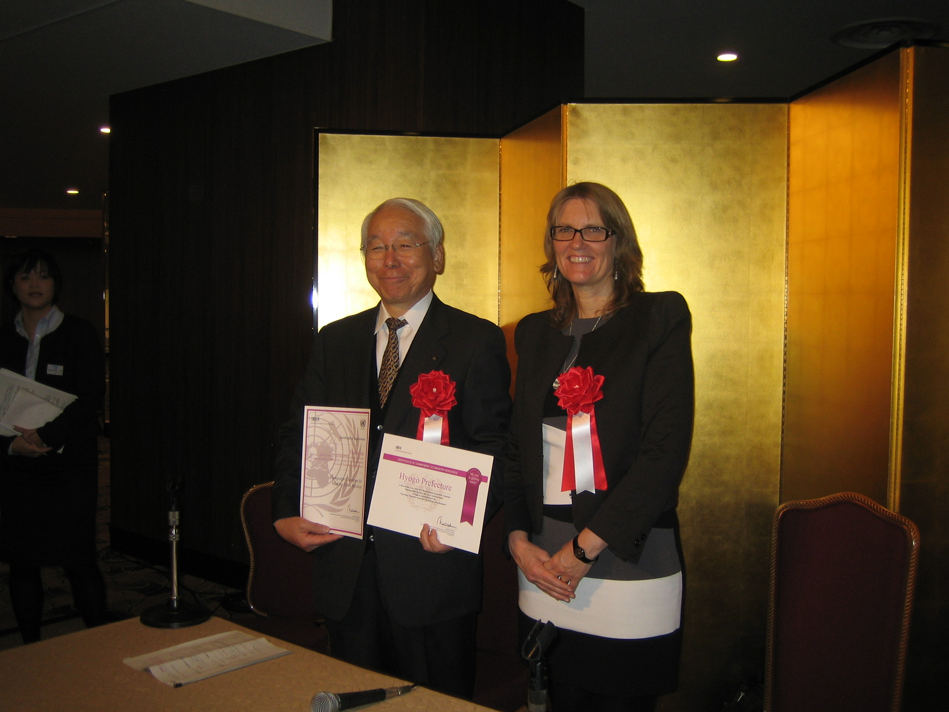
Mr. Ido received the UNISDR Campaign Champion certificate and Role Modal City certificate from the Deputy Director of UNISDR in Kobe on 12 January 2011.

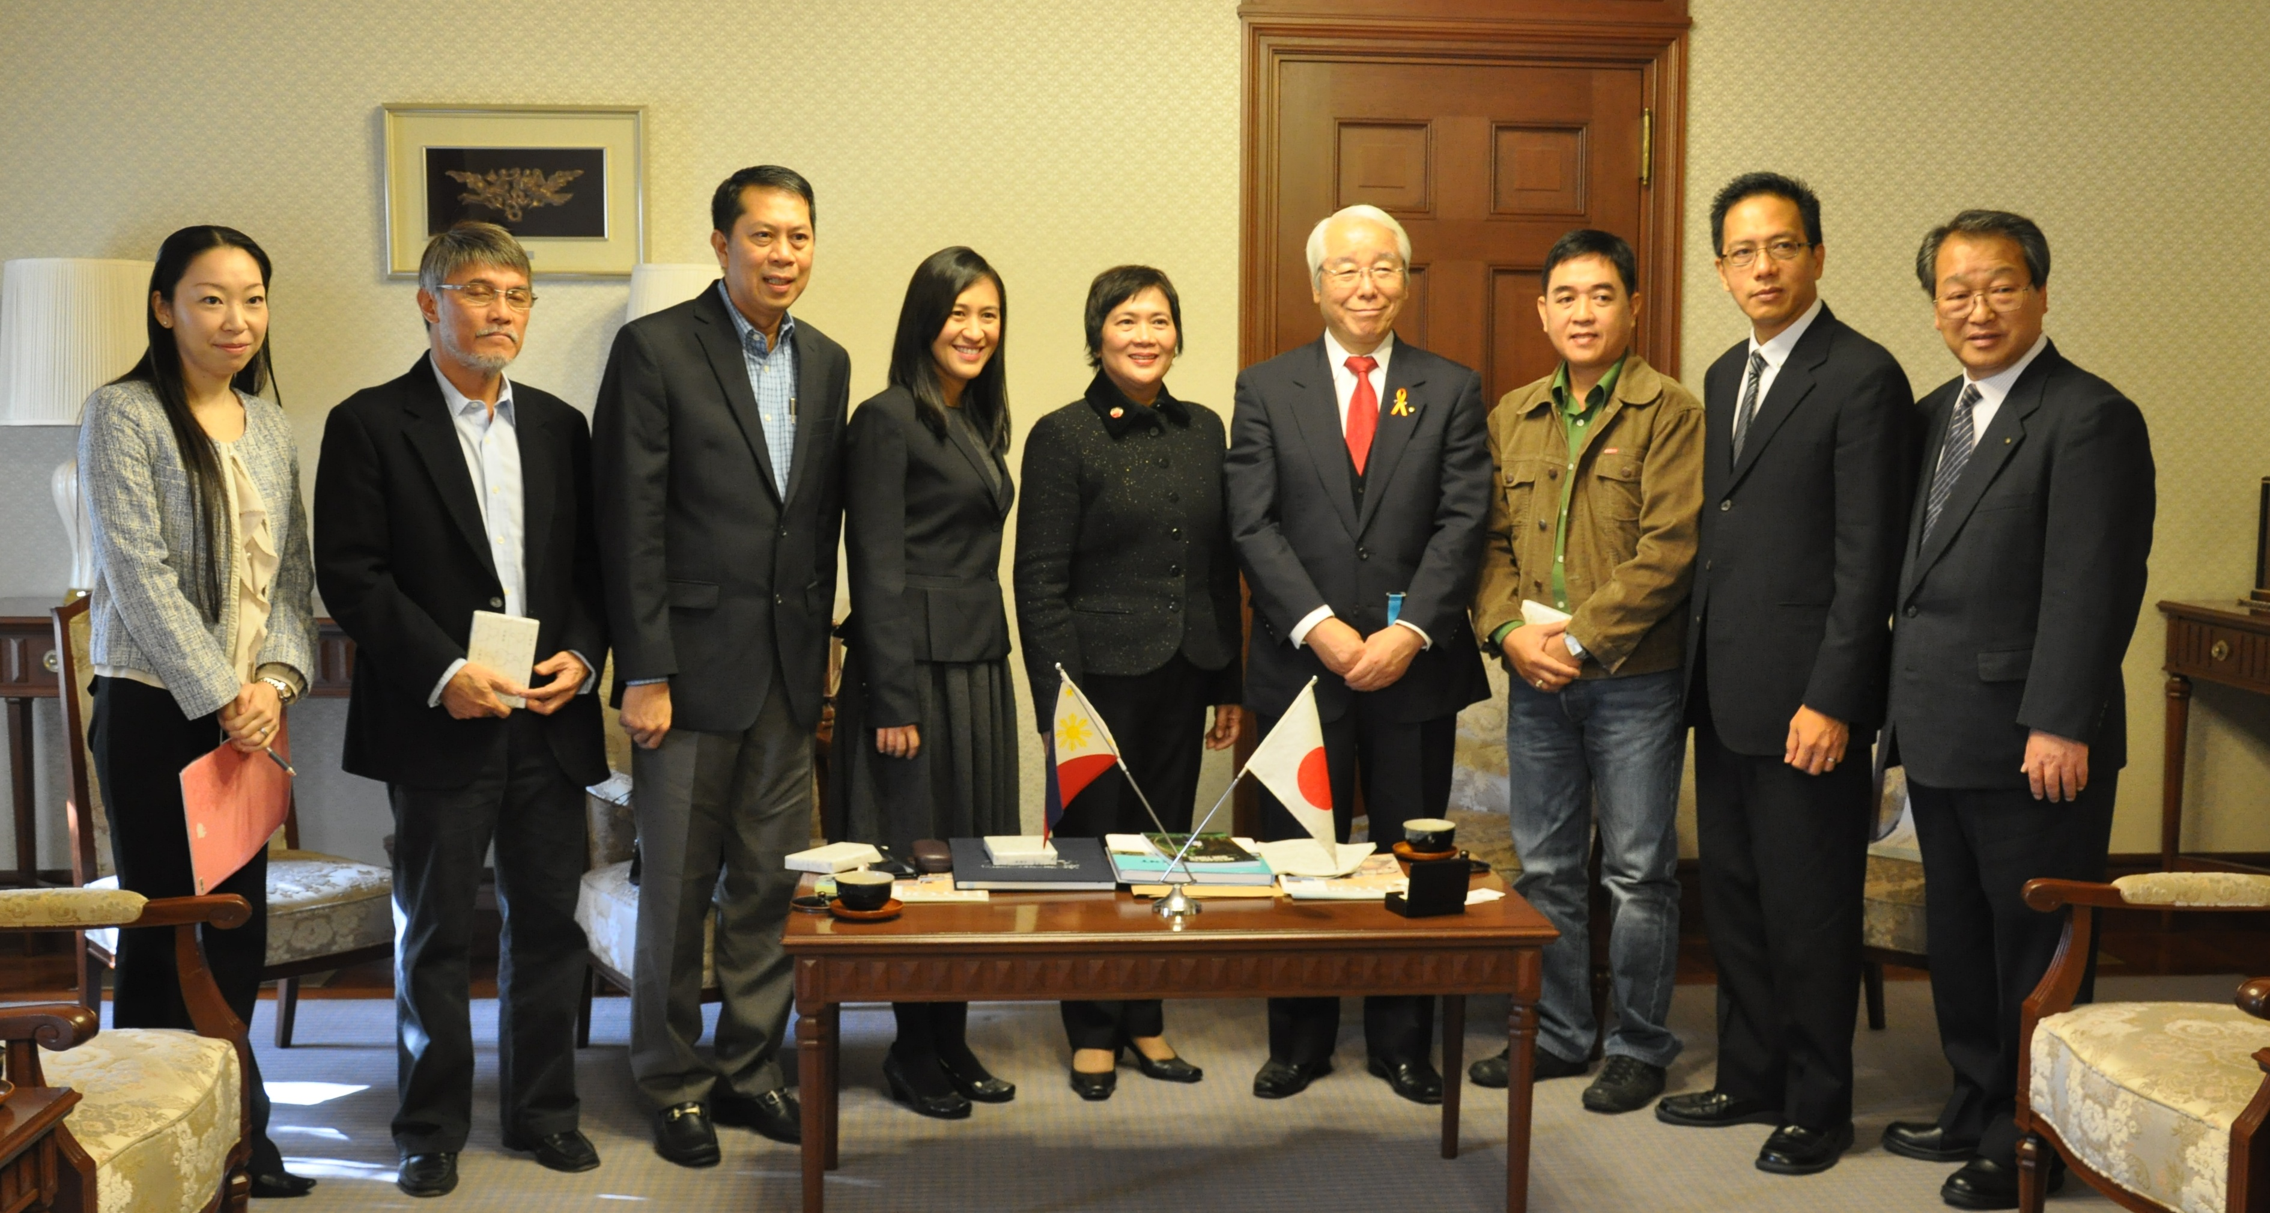
Mr. Ido received the courtesy call by the heads of Filipino local governments who participated in the “UNISDR Caucus on Linking DRR and CCA for Effective Risk Governance in the Philippines” organized by UNISDR Bangkok and Hyogo Offices in Kobe from 20 – 25 November 2011.

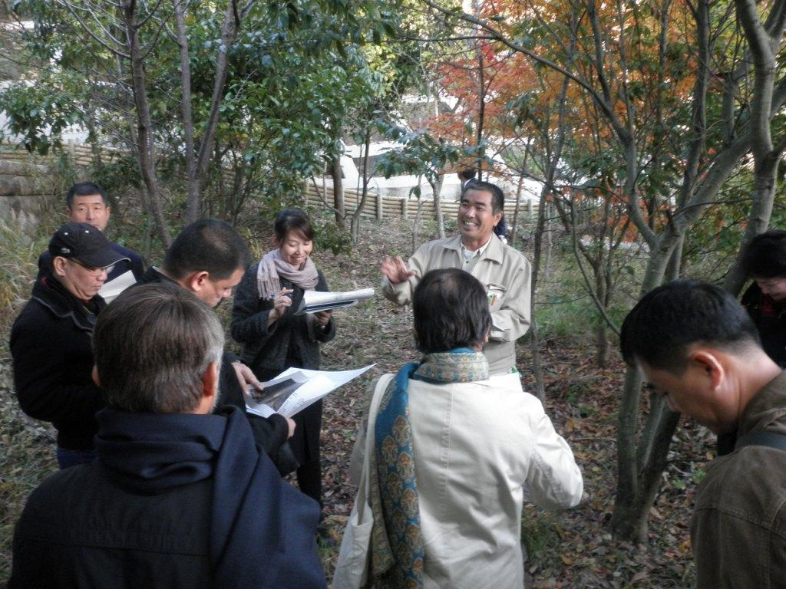
As part of city-to-city learning, Hyogo Prefecture shared its DRR-CCA knowledge and lessons learned, including site visits to Sabo dam, with the participants of the “UNISDR Caucus on Linking DRR and CCA for Effective Risk Governance in the Philippines”.

