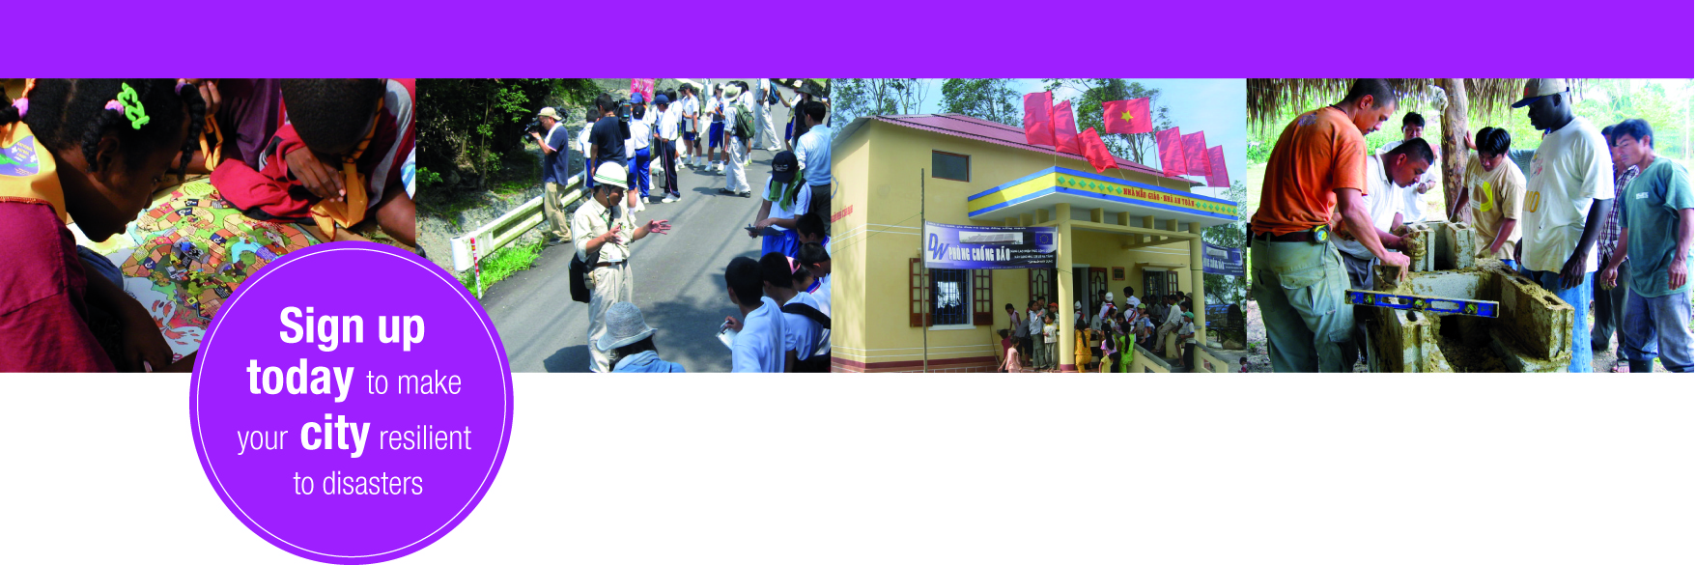

ADVOCATE APPLICATION FORM
Become an advocate and be part of the resilient cities solution.

- Name and full contact details (should include – professional position, work address, mobile, telephone etc.):

- Email:

- Highest Educational background:

- Coverage: (countries, region that the Advocate is proposing to cover or support by his or her affiliation with the Resilient Cities Campaign)

- Languages spoken and written:

- Area of expertise:

- Disaster risk reduction related training experience and exposure:

- Motivational letter (Approximately 600 words)
Please include
- why you are an ideal Advocate of Disaster Risk Reduction in your locality
- What attracted you to apply to become an official advocate of the UNISDR Making Cities Resilient Campaign.
- What you can offer the campaign with your background and personal capacities.
- What you hope you can aspire to provide the campaign.
- What you hope to achieve as an official Advocate.
- What you aim to get out of being an official Advocate.

- Twitter account handle:
If you do not currently hold a twitter account, we strongly recommend that you start for the reason that social media is recognized as a powerful tool in advocating in communities through technology, particularly to future generations.

- Links to videos, interviews, blogs, websites, publications or other such related documentation/multimedia:

- Are you available and interested to support cities in your country or nearby region?

- If yes, then please mention your coverage: (countries, region that the Advocate is proposing to cover or support by his or her affiliation with the Resilient Cities Campaign)

- Short Biography

- Proposed campaign activities

- Video links

