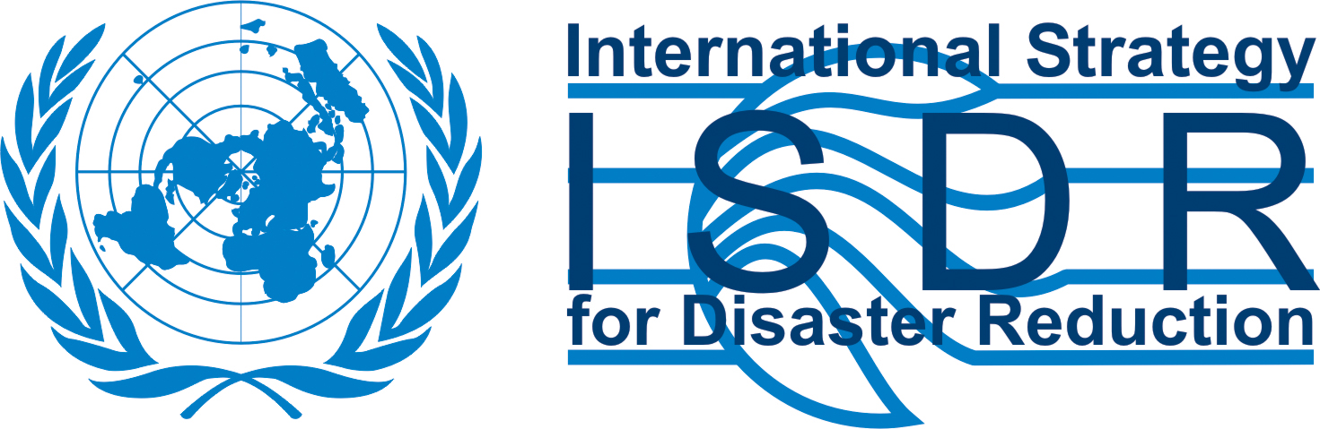

PRESS RELEASE

A LOCAL SCHOOL IN SEVERELY TSUNAMI-STRICKEN AREA OF SOUTHERN THAILAND CELEBRATES THE INTERNATIONAL DAY FOR DISASTER REDUCTION

Pang Nga, 11 October 2006 – Knowledge is power and education on disaster risk reduction is vital if vulnerable communities are to be better prepared and protected against the impact of future disasters.

This is the lesson learnt by the Principal of Tab Lamu School, in Pang Nga Province, Thailand, following the devastation caused by the 2004 Indian Ocean tsunami and the despair in which his school and the local community were left. Raising awareness and educating the school children and the local community on the way to empower themselves to become more resilient to disasters has now become a top priority for Tab Lamu School and his Principal.

This proactive approach goes along the lines of the 2006-2007 World Campaign on Disaster Reduction led by the United Nations International Strategy for Disaster Reduction (UNISDR) on the theme of “Disaster Risk Reduction Begins at School – One lesson at school can save a hundred lives” and the “Knowledge-based Capacity Building in Early Warning System” project developed by the National Disaster Warning Centre (NDWC) of Thailand.

With the support of the UNISDR Asia and Pacific and the NDWC, the Tab Lamu School will be organizing the first local celebrations of the International Day for Natural Disaster Reduction at the school and community levels with the participation of the Ministry of Education, the Department for Disaster Prevention and Mitigation (DDPM) of the Ministry of Interior of the Royal Government of Thailand as well as the Asian Disaster Reduction Centre (ADRC) from Kobe, Japan.

On that occasion, the school children will be invited to present their drawings and photos of previous disasters as well as the vulnerability and risk maps developed jointly with the local community and village leader and will engage into an interactive discussion with their community and the above representatives, on the role of children and the local community in identifying the overall community’s vulnerabilities and threats and in ensuring its protection against future disasters, including through appropriate evacuation roads. NDWC and DDPM will introduce basic concepts of early warning and disaster risk management whilst Ministry of Education and ADRC will share their experience and recommendation on mainstreaming disaster risk reduction into school curricula.

For more information, please contact:

UNISDR Asia and Pacific National Disaster Warning Centre
C/o UNESCAP- Rattanatibet Rd, Bang KraSor Muang
UN Conference Centre Nonthaburi 11000 - Thailand
Rajdamnern Nok Avenue Tel: +66 2 589 2497
10200 Bangkok, Thailand Emergency Call Centre: 1860
Tel: +66 2 288 2745
Email: isdr-bkk@un.org, www.unisdr.org/asiapacific

