
UNESCAP


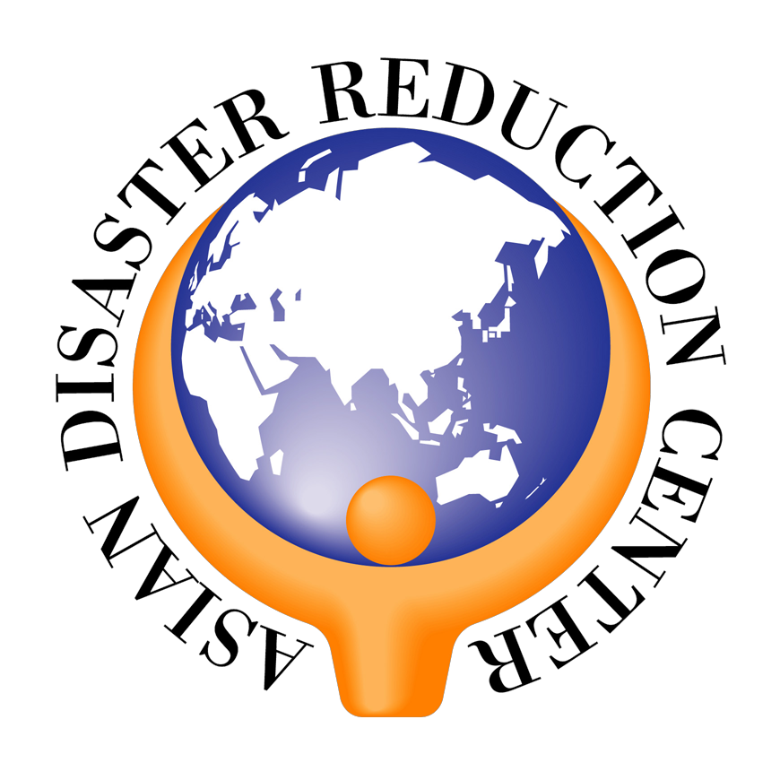

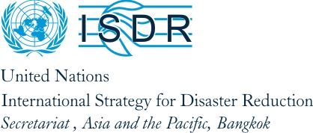





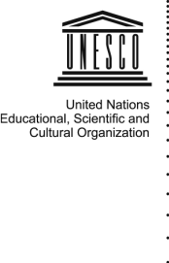
UNECAP
UNESCAP

Asia-Pacific Regional Workshop on School Education and Disaster Risk Reduction

8-10 October 2007, Bangkok, Thailand

Jointly organized by UNESCO, UNICEF, UNESCAP, UNCRD, UNOCHA, IFRC, ASEAN, ADRC, ADPC, ASB and UN/ISDR Asia and Pacific

Final Programme

With the support of AusAID, ECHO, the World Bank and GTZ

Monday 8 October

8:30-9:00 Registration

9:00-9:35 Opening Ceremony
Master of Ceremony: Jerry Velasquez, UN/ISDR Asia and Pacific

- Dr Raj Kumar, Principal Officer of UNESCAP
- Video Message by Director, UN/ISDR
- Statement by Mr. Sheldon Shaeffer, Director UNESCO Regional Office for Asia and Pacific
- Mr. Kazunobu Onogawa, Director, UNCRD
- Welcoming address by Mr. Banyat Jansena, Deputy Minister of Interior, Thailand

9:35-10:00 Coffee Break

10:00-12:00 Session 1: Integrating Disaster Risk Reduction into School Curricula
Leading Agency: UNESCO
Chair: Mr. Derek Elias, Programme Specialist, Education for Sustainable Development, UNESCO Bangkok

- Mr. Masakazu Goto, Senior Researcher, National Institute for Educational Policy Research, Japan -
- Ms. Sararat Leepaiboon, Education Officer, Office of the Basic of Education Commission, Thailand
- Mr. Gusmayadi Muharmansyah, Project Manager, Directorate of Kindergarten and Primary School Development, Indonesia
- Mr. Wilfred Perera, Assistant Director General, National Institute of Education, Sri Lanka
- Mr. David Murray, Director, Educating NZ, New Zealand

Discussion

12:00-13:00 Lunch break

13:00-14:45 Session 2: Mainstreaming Disaster Risk Reduction into the Education Sector
Leading Agency: ADPC
Chair: Dr. Nescha Teckle, Regional CPR Team Leader, BCPR, UNDP
Co Chair: Mr. Loy Rego, Director and Team Leader, Disaster Management Systems Team, ADPC

Presentations
- Mr. Loy Rego and Mr. Sanjaya Bhatia, ADPC - ‘What is Mainstreaming of DRR into Education Sector’
- Mr. Eng Kimly, Deputy Director, Pedagogical Department, Ministry of Education Youth and Sports, Cambodia and Dr. Keovivone Outhachak, Curriculum Developer, Pedagogical Department, NRIES, Lao PDR - Integrating DRR into School Curriculum in Cambodia and Lao PDR
- Mr. Hermana Somantrie, Head, Secondary Education, National Curriculum Center, Indonesia - Integrating DRR into School Curriculum in Indonesia,

Invited comments from panelists
- Mr. Aslam Alam, National Programme Management Expert, CDMP, Bangladesh
- Mr. R.K. Singh, Deputy Director, Ministry of Home Affairs, Government of India /Ms. Balaka Dey, Programme Associate, UNDP, India
- Mr. Wilfred Perera, Assistant Director-General, National Institute of Education / Dr. Patrizia Bitter, Senior Advisor, GTZ , Sri Lanka

Presentations
- Engr. Oliver Hernandez, DepED, Philippines - Building safer schools in Philippines,
- Mr. Hung Deputy Director, Department of Education and Training, Vietnam - Tien Giang Provincial Partnership on School Flood Safety Initiatives, Vietnam,
- Mr. N.M.S.I Arambepola and Mr. Loy Rego, ADPC - Lessons learned from mainstreaming DRR Education Sector- ADPC experience over last 15 years

Invited comments from panelists
- Ms. Akiko Nakamura, Senior Researcher, ADRC
- Mr. Farokh Parsizadeh, Director of Public Education, IIES, Iran
- Mr. Barry Adhitya, Project Manager, Muhammadiyah Disaster Management Center, Indonesia
- Actionaid Bangladesh

Wrap-up

14:45:15:45 Session 3: Disaster Risk Reduction Education Materials
Leading Agency: RISK RED
Chair: Marla Petal, co-Director, Risk Red

- Mr. Saidur Rahman, Director, Bangladesh Disaster Preparedness Centre (BDPC) - Two decades of experience and the successes of indigenous knowledge in DRR education
- Ms. Marla Petal, co-Director, Risk Red - New materials for DRR education, the Global Online Library, content management system and networking our community of practice
- Mr. Andy Naslas, Regional Advisor, Save the Children, Sweden - Distinguishing between hazard awareness and response preparedness education vs. risk reduction education
- Ms. Patrizia Bitter, Senior Advisor, GTZ, Sri Lanka - Evidence-based development of educational materials, and programs as prelude to scaling-up.
- Mr. Sanjay Bhatia, Former UNDP/Government of India - Successes with cultural and folk arts to DRR education
- Mr. Manu Gupta, Joint Director, SEEDS India - Successes with games, toys, and models to support DRR education
- Ms. Mayfourth Luneta, Center for Disaster Preparedness (CDP), Philippines - Successes with child participation in supporting DRR education
- Jenefer de la Cruz, Plan International - Success with theatre in supporting DRR education
- Khusan Tursunov, Hayot Uzbekistan - Successes with video to support DRR education

Discussion

15:45-16:00 Coffee break

16:00-16:45 Working group discussions
- Integrating disaster risk reduction into school curricula
- Mainstreaming disaster risk reduction into the education sector
- Disaster risk reduction education materials
- Education as an essential component in reducing the socio economic impact of disasters

16:45-18:00 Report of Working Groups and discussion

18:00 Cocktail reception

Venue: Atrium, UN Conference Centre

Tuesday 9 October

8:30-10:00 Session 4: Making School Buildings Safe from Disasters
Leading Agencies: UNCRD and ADPC

- Mr. Bishnu Hari Pandey (UNCRD) “Issues and opportunities to make schools safe from disasters “

Panel discussion on “Institutionalization of school safety at national level”
Chair: Mr. Kazunobu Onogawa, Director, UNCRD

- Mr. Loy Rego, ADPC
- Mr. Josefani Bola, Director, Centre for Appropriate Technology and Development (CATD), Fiji
- Dr. Krishna Pribadi, Associate Professor, ITB Indonesia
- Mr. Rajesh Kishore, CEO, Gujarat Disaster Management Authority (GSDMA), India
- Mr Khusun Tursunov, chairperson, Social Environmental Association, Tashkent Uzbekistan
- Mr. Khizer Omer, Aga Khan Planning and Building Service, Pakistan

Comments to panel by Mr. Amod Mani Dixit, NSET

Discussion

10:00-10:30 Coffee break

10:30-12:00 Session 5: Non-Formal Education and Disaster Risk Reduction
Lead Agency: IFRC
Chair: Mr. Bernd Schell - German Red Cross

- Ms. Balaka Dey , UNDP India
- Mr. Muhammad Saidur Rahman, Director, Bangladesh Disaster Preparedness Centre (BDPC)
- Action Aid
- Mr. Phung Van Hoan, Under - Secretary General and Director of Social Work Department, Vietnam Red Cross Society:
- Indonesia Red Cross Society

Discussion

12:00-13:00 Lunch break

13:00-14:00 Working group discussions
- Making school buildings safe from disasters
- Non formal education and disaster risk reduction
- Addressing the special needs of disabled school children in DRR
- Recognizing the role of children in DRR

14:00-15:00 Working Group reports to Plenary and discussion

15:00-15:30 Coffee break

15:30-17:00 Session 6: Addressing the special needs of deaf school children
Leading Agencies: ASB Indonesia and Iran Institute of Earthquake Engineering and Studies (IIEES)
Chair: Ms. Sae Kani, Programme Manager, ASB

- Mr. Jeong Hong, ESCAP Disabled People Department
- Sae Kani, Programme Manager, ASB
- Ms. Galuh Sukmara, ASB
- Interactive session with deaf students from Thungmahamek School, Bangkok, Thailand
- Mr. Farokh Parsidazeh , Iran Institute for Earthquake Engineering Sciences (IIEES),
- Film

17:00-18:00 Parallel Session A: Guidelines on Integrating DRR into School Curricula
Leading Agency: ADPC

Parallel Session B: Guidelines for Safer School Constructions –
Leading Agencies: UNCRD and NSET

Wednesday 10 October

09:00 – 09:45 Commemoration on the occasion of the International Day for Natural Disaster Reduction

- United Nations Secretary General’s Message on the occasion of the International Day for Disaster Reduction
- Opening message from Dr. Raj Kumar, Principal Officer of UNESCAP
- Statement from, Dr. Bhichit Rattakul, a.i., Executive Director of ADPC
- Inaugural speech by Director General, Department for Disaster Prevention and Mitigation, Ministry of Interior
- Statement of Dr. Raman Letchumanan, representative of ASEAN Committee on Disaster Management

09:45:10:15 Coffee break

10:15-12:00 Session 7: Education as an essential component in reducing the socio economic impact of disasters
Leading Agency: UNESCAP

- Mr. Le-Huu Ti, Chief Sustainable Development and Water Resources Section, ESDD, UNESCAP - Assessment of Socio-economic Impacts of Natural Disasters as Basis for Education on Disaster Risk Management:
- Perspectives of an ISDR Training Centre in the Region, National Emergency Management Training Agency, Republic of Korea
- Education for “Safer Living”, an experience of Hong Kong, China under severe annual impacts of typhoons, UNESCAP
- Dr Penung Warnitchai, Professor of the Asian Institute of Technology, Formal education for more effective disaster management, Thailand
- Experience of Channel 9 on Education on risk management of natural disasters for socio-economic development in Thailand, Representative of MCOT Public Co. Ltd.

Discussion

12:00-13:00 Lunch

13:00-14:30 Session 8: Children’s Voices – Let Our Children Teach Us
Leading Agencies: UNICEF and UN/ISDR

Chair: Mr. Gary Ovington, UNICEF

      - Bangladesh - Upukulio Model High School
- Mr. Md. Fazlul Quader, Head Master
- Mr. Md. Saddam Hossain, Student
      - India - H B K Kapadia High School
- Ms. Renu Seth, Management Representative
- Mr. Akash V. Mehta; Student Grade X
      - Indonesia - SMPN 2 Semelue Timur
- Mr. Firmanudin, Principal
- Ms. Baby Febri Kurnia, Student
      - Iran - High School in Narmashir
- Mr. Mansour Sadeghizadeh, Principal
- Ms. Nazanin Ramezanzadeh, Student
      - Philippines - Pag-asa National High School
- Ms. Roditha Hidalgo, Teacher
- Mr. Dexter Arnaldo, Student
      - Thailand - 36th Rajaphajanugroh School
- Mr. Nawarat Smutkota, Principal
- Mr. Suriya Shenaka, Student Grade 9

Discussion

14:30- 16:00 Recommendations from Working Groups and presentation of Guidelines
Discussion

16:00-16:30 Coffee break

16:30-17:30 Special Addresses
      - Hon. Thompson Seinavao Tasso, Minister of Education, Vanuatu
      - Hon. Varakorn Samakoses, Deputy Minister of Education, Royal Thai
Government
      - Mr. Md. Safiullah, Joint Secretary, Ministry of Education, Bangladesh

17:30-18:00 Closing Ceremony
      - Workshop Summary
      - Closing remarks, by UN/ISDR on behalf or the Education Task Force

