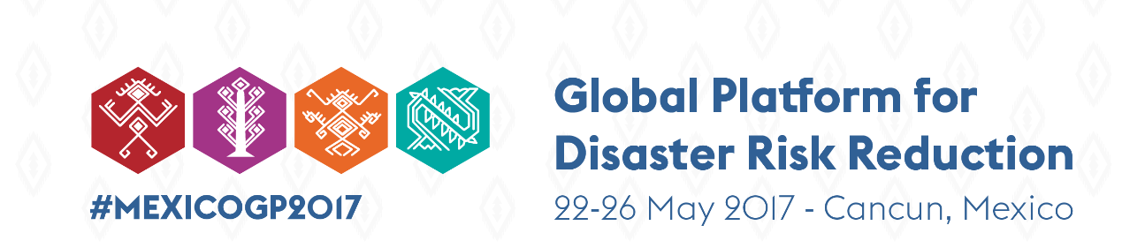

Reporting for the Chair’ Summary to be used by Organising Teams

Important Note: The summary needs to be cleared by the Co-chairs of the session BEFORE being circulated to the Chair’s Summary drafting team by the UNISDR Focal Point for the session.

Date
Thursday 25 May 2017, 17:00-18:30 hrs
Title of the Session
Working Session on Inclusive and People Centred Disaster Risk Reduction
Recording Reference Number: GP17WS12
Name of co-chairs
Md. Abul Kalam Azad, Principal Coordinator (SDGS) of the People's Republic of Bangladesh
Dr. Natalia Kanem, Deputy Executive Director for Programmes at UNFPA
Name of UNISDR Focal Point and sender of this summary report
Stefanie Dannenmann-Di Palma, Deputy Head, UNISDR Europe (dannenmann@un.org)
Summary of the main substantive considerations expressed, clustered around the 4 Sendai Priorities and the 5 areas of special focus of the Chair’s Summary Skeleton, as applicable
Priority 1 – Understanding disaster risk
Priority 2 – Strengthening disaster risk governance to manage disaster risk
Priority 3 – Investing in disaster risk reduction for resilience
Priority 4 – Enhancing disaster preparedness for effective response and to “Build Back Better” in recovery, rehabilitation and reconstruction
Areas of Special Focus
- Monitoring the Sendai Framework implementation
Ensuring inclusive and people-centred disaster risk reduction through Sendai Framework monitoring and evaluation mechanisms is key to protecting the well-being of high-risk communities. Further collection and analysis of local and regional data disaggregated by age, sex, disability and mobility status is imperative in understanding the impact of inclusive governance, and creating accountability to marginalised groups.

- Achieving target E – Substantively increase the number of countries with national and local disaster risk reduction strategies by 2020
- Coherence with the sustainable development and climate change agendas

- Gender-sensitive and inclusive disaster risk reduction
- The working session highlighted the importance of understanding the risk faced by children and youth when developing national strategies but at the same time to build on their capacities. The example of Indonesia highlighted the successful mainstreaming of child-centred climate change and disaster risk assessments (referred to as APIFA) within existing and new programmes (e.g. Family resilient programme, safe schools, ‘resilient village’, ‘child-friendly village’ and ‘child friendly district/city’ programmes).

- Achieving inclusion for all requires a multi-action systems approach. For inclusion to become a lived reality, three interconnected actions are needed: 1) building knowledge & skills, 2) changing attitudes and belief systems, and 3) promoting inclusive governance. These will engage marginalised populations and supporting organisations as co-producers of risk solutions.

- Increase the availability and use of data to inform public policy, measure and report disaster risk reduction through gathering disaggregated data and innovative practices to measure and report on risk reduction, including through leveraging new technologies. In particular, youth should be engaged in the gathering and use of data for planning, budgeting, monitoring and evaluating impact and progress to ensure inclusiveness and enhance accountability in disaster risk reduction.

- Health, protection, education and income-generating activities underpin sustainable empowerment of women and youth. The impacts of disasters on unpaid care work goes largely unnoticed and is not usually included in calculations of disaster losses. Enhanced and broader understanding of this issue, as well as, data on this issue would strengthen arguments for gender-inclusive policies and services to expand women’s leadership in disaster risk reduction.

- International cooperation initiatives, including what is expected from the UN System

Key, precise, specific actions points, recommendations, with expected timeframes, as summarized by the Co-chairs when closing the session (no worth in repeating what already agreed to in the Sendai Framework)
- Disaster Risk Management Committees should include gender, age and persons with disabilities at all level.

- Compile and publish inclusive lessons learnt and best practices globally to improve prevention and preparedness for use by a variety of stakeholders, including civil protection agencies.

- Train and empower women and volunteers by providing access and full engagement in decision-making processes.

- Endorsed the Dhaka Declaration on Disability and Disaster Risk Management and urges for member countries to implement Dhaka Declaration and report on it when submitting the Sendai Monitoring in 2019. Dhaka Declaration calls for:
  - All level of Disaster Risk Management Committees should have gender and age sensitive representation of persons with disabilities
  - inclusive Community Risk Assessment and Risk Reduction Action Plan framework and guidelines for disaster risk management programmes
  - establish and/or support local and national multi-stakeholders’ platforms to implement the Sendai Framework through active citizen engagement
  - an effective mechanism and guidelines to compile sex, age and disability disaggregated data at pre- and post- disaster situations
  - people centred multi-hazard early warning system
  - to enforce accessible and resilient infrastructure models including schools, hospitals and shelters following the principles of universal design
  - replicate accessible and affordable technology, device and equipment for inclusive humanitarian response
  - each region will declare focal points to represent in the advocacy group on Inclusive DRM to be formed by UNISDR, and National and Regional DPOs

Specific Commitments expressed by any of the participants

