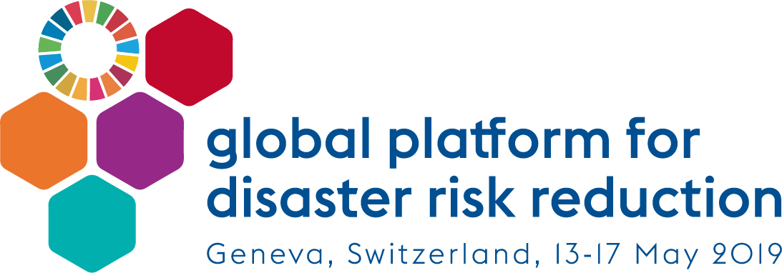

Mainstreaming Gender throughout the 2019 Global Platform discussions

- Fostering women’s participation in the Global Platform
- UNISDR’s efforts in promoting women’s participation in international meetings has shown a substantial increase from 30% of women at the 2015 World Conference on Disaster Risk Reduction to 40% at the 2017 Global Platform for DRR (May 2017, Cancun, Mexico).
- Continued advocacy is being made in this respect with Governments to promote gender balanced delegations and promote senior / high-level women’s representation at the 2019 Global Platform for DRR on the occasion of SRSG and Director’s bilateral meetings, at ISDR Support Group meetings and through targeted approach to gender focal points in Permanent Missions.

- Promoting Gender Parity Panels
- As per UNISDR’s Strategy on Gender Equality and Parity and related commitment to achieve gender parity by 2026, UNISDR is committed to actively promoting Gender Parity Panels throughout the Global Platform sessions. These efforts are expected to lead to an equal representation between men and women in functions as varied as sessions chairs, panelists and moderators. Neither all-male nor all-female panels are desirable and should be avoided.

- Giving a voice to women in Global Platform discussions
- Women will be encouraged to take active leading and speaking role throughout the 2019 Global Platform discussions, be it in formal sessions as a (co)chair, (keynote) speaker, moderator, facilitator or discussant from the floor.
- Women have been invited to join the Organizing Teams of the 2019 Global Platform substantive sessions (High level Dialogues, Plenaries, Special Session) to help shape these discussions. Particular efforts have been made to ensure gender parity of the Organizing Teams to promote gender-sensitive discussions to take place throughout the organization process.
- A Special Session on Women Leadership in Disaster Risk Reduction will be organized on Day 1 of the formal program of the Global Platform and will feature women leaders with outstanding achievements and/or contributions to the Sendai Framework implementation.

- Building for informal women groups discussions and consultations
In addition to the Special Session organized as part of the Global Platform’s formal program, the following opportunities will also be provided to women and women groups:
- Preparatory days to organize informal discussions and consultations among women and women groups to share experiences, good practices so that they can position and prepare themselves for discussions during the formal program.
- Side Events to promote gender equality, parity, women empowerment and leadership in DRR. The outcomes of the Side events will be reflected in the Global Platform proceedings.
- The Ignite Stage will continue to represent interactive opportunities for women groups to showcase their work and achievements in disaster risk reduction
- NEW ! The Innovation Platform will feature innovative approaches and achievements in DRR. Innovation concerning gender and disaster risk reduction is strongly encouraged.
- NEW ! Learning Labs will be organized on specific topics to facilitate peer-to-peer learning among Governments and stakeholders to accelerate the implementation of the Sendai Framework. Strong participation of women will be promoted and fostering learning on gender work welcomed.

- Please note:
- Only 15 side events slots will be offered at the 2019 Global Platform!
- Demonstrating gender balance of the side events request will increase the likelihood of being accepted.

- Check the GP19 Website regularly so that you do not miss deadlines for submission of requests for side events, informal consultations on preparatory days, Ignite Stage and Innovation Platform!

For more information, please approach UNISDR’s Gender Focal Point at rosec@un.org

