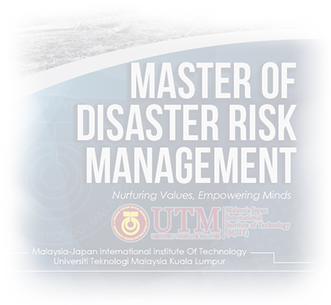
APPLICATION FORM FOR
SHORT-TERM PROFESSIONAL TRAINING (CERTIFICATE)
Malaysia-Japan International Institute of Technology (MJIIT)
Universiti Teknologi Malaysia (UTM) Kuala Lumpur

Introduction
MJIIT-UTM offers short-term professional training programs for those who interested to obtain practical knowledge and technical skills related to disaster risk management. Participants who completed the professional training can apply for credit transfer, within 3 years for the master of Disaster Risk Management (MDRM).
A prominent and top Japanese Professors will be leading the course supported by local professors and lecturers. Each course is allocated for only 2 weeks. You may reserve your seat for the selected course as offered below in advance, as place is very limited and early registration/payment in strongly advisable.

Venue:
Malaysia-Japan International Institute of Technology
Universiti Teknologi Malaysia
54100 Jalan Sultan Yahya Petra
Kuala Lumpur, Malaysia

- PERSONAL DATA
  - Full Name as in Identification Card/Passport:
_____________________________________________________
  - NRIC/Passport No. : _____________________________
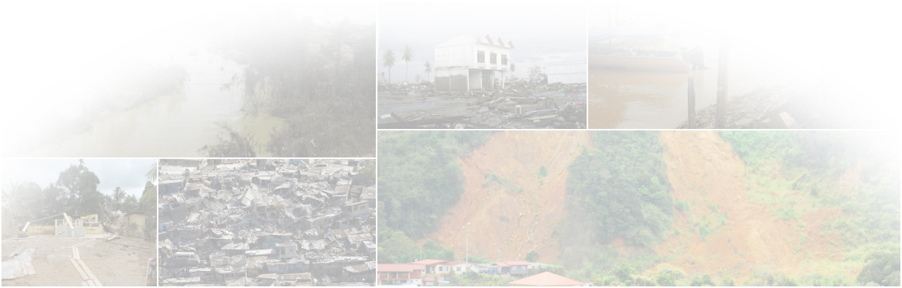
  - Title : _____________________________

  - Organization : _____________________________

  - Correspondence address : _____________________________
_____________________________________________________
  - Postcode : ______________

  - City : _____________________________

  - State : _____________________________

  - Country : _____________________________

  - Contact Phone No. : _____________________________

  - Mobile Phone No. : _____________________________
  - Office Phone No. : _____________________________

  - Fax No. : _____________________________

  - Primary Email : _____________________________

  - Secondary Email : _____________________________

  - Country of Birth : _____________________________

  - Date of Birth (dd-mm-yyyy) : _____________________________

  - Nationality : _____________________________

  - Gender : ☐Male ☐Female

- ACADEMIC QUALIFICATION (Indicate highest academic qualification)
  - Name of Institution:
_____________________________________________________
  - Country: _____________________
  - Year of study: From ______ to ______ (yyyy)
  - Name of Degree Awarded: _________________________________
  - Level of Degree Awarded:
☐PhD ☐Master ☐Degree ☐Diploma
☐Others: ________________________

  - Date of Degree Awarded/Been Completed:
Month _____ (mm), Year_____ (yy)
  - Classification Achieved: ☐First Class ☐Second Class Upper
☐Second Class Lower ☐Post Graduate Diploma
☐Others: __________________________
  - Cumulative Grade Point Average (Obtained/Maximum):
_____ out of _____

- WORK EXPERIENCE (Indicate current work)
  - Position:
___________________________________________________
  - Period of Employment:
From ____________ (dd-mm-yyyy) To ____________ (dd-mm-yyyy)
  - Name of Employer: ___________________________________

  - Employer’s Email Address: ______________________________

  - Employer’s Telephone No.: ______________________________

- ENGLISH LANGUAGE PROFICIENCY
  - English Language Qualification: ☐TOEFL ☐IELTS ☐MUET
  - Score Points: ____________

- ATTACHMENTS REQUIRED CHECKLIST (Please send together with this application via email)

  - Photograph ☐
  - Copy of Identity Card (MyKad/Front Page Passport) ☐
  - Complete Curriculum Vitae (CV) ☐

- LIST OF COURSES (Please tick the course you are interested to attend)
Code |  | Core Courses | Date
☐ | MMJD 1113 | Integrated Disaster Management | 5 - 23 September 2016
☐ | MMJD 1123 | Disaster Data Management and Forecasting | 26 September - 7 October 2016
☐ | MMJD 1133 | Control Measures and Mitigation Planning | 10 - 21 October 2016
☐ | MMJD 1143 | Emergency Response Planning and Communication | 14 - 25 November 2016
☐ | MMJD 1153 | Recovery and Reconstruction Management | 28 November - 2 December 2016
 | Elective Courses (Technical)**
☐ | MMJD 1213 | Control Measures for Landslides and Debris Flow | 27 February - 10 March 2017
☐ | MMJD 1223 | Flood Forecasting and Hazard Mapping | 13 - 24 March 2017
☐ | MMJD 1233 | River Channel and Irrigation Design | 27 March - 7 April 2017
☐ | MMJD 1243 | Geoinformation in Disaster Risk Assessment | 10 - 21 April 2017
☐ | MMJD 1253 | Flood Hydraulics and Mechanics of Sediment Transportation | 24 April - 5 May 2017
 | Elective Courses (Policy & Management)**
☐ | MMJD 1263 | Disaster Education and Preparedness | 8 - 19 May 2017
☐ | MMJD 1273 | Community and Social Resilience | 22 May - 2 June 2017
 | MMJD 1283 | Public Health Policy and Management | 5 - 16 June 2017
☐ | MMJD 1293 | Healthcare in Emergencies and Rehabilitation | 19 - 30 June 2017
☐ | MMJD 1203 | Disaster Psychology | 03 - 14 July 2017

** subject to amendment
FEE INFORMATION

Fee for professional course is RM 2,500 per course

PAYMENT DETAILS

Payment may be made via bank transfer to | UNIVERSITI TEKNOLOGI MALAYSIA
Account Number | 14032010035630
Swift Code | BIMBMYKL
Bank Name | Bank Islam Malaysia Berhad
Bank address | Tingkat Bawah, Bangunan Ibu Pejabat Lembaga Tabung Haji, Jalan Tun Razak, 50400 Kuala Lumpur, MALAYSIA.
Message | Short-Term Professional Training Course (Certificate) (Please write the participant’s full name)

For further information, contact us:

Dr. Khamarrul Azahari Razak (019-364 9495)
Dr. Shuib Rambat (010-2788387)
Dr. Muhamad Askari (011-28663773)

Universiti Teknologi Malaysia (UTM) Kuala Lumpur
54100 Jalan Sultan Yahya Petra,
Kuala Lumpur, MALAYSIA.

- : 03-2203 1517 / 018 2251 517
  - : 03-2203 1266
: mdrm@utm.my, muhaskari@utm.my, shuibrambat@utm.my
@ : http://mjiit.utm.my/mdrm/

