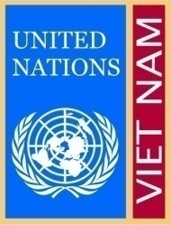
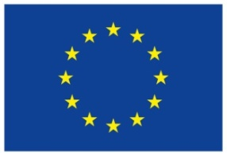
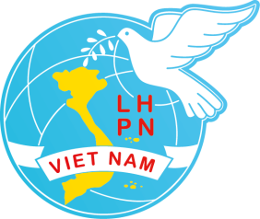
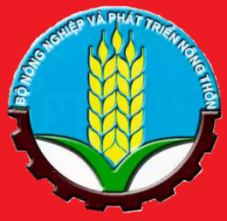

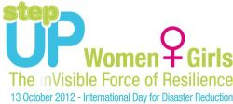

Event: Advocacy Event on the Occasion of the International Day for Disaster Reduction 2012 in Hanoi, Viet Nam

Date: 12thOctober 2012

Background
On the Occasion of the Viet Nam is among countries that are seriously affected by the adverse effects of climate change, which is evident in the increase, changing patterns and the nature of natural hazards Viet Nam faces. Most of the population lives in low-lying river basins and coastal areas while more than 70% of the population is estimated to be exposed to risks from multiple natural hazards. Coastal areas are regularly severely affected by typhoons, storms and floods. Those exposed Vietnamese provinces thus need to develop a long-term capacity to prepare for and respond to natural disasters.

Preparing for disasters relies strongly on the full support of both sexes, and women have capacities, talents, skills and knowledge that should be capitalized upon. However, there is a lack of recognition of women's roles and contribution to disaster risk reduction and management actions. Understanding of gender roles in the context of climate change and disaster risk reduction is still limited and stereotypes regarding women's and men's roles in DRR still prevail, meaning that women are often only seen as victims and not as crucial actors, and that recovery addresses mainly male members of households. Female headed households tend to be among those with least resilience.

Although remarkable progress has been made over the past years, important gender differences still remain. These differences are reflected in women’s and men’s contributions to productive and reproductive work, formal and informal employment and salaries, poverty levels, literacy rates, their access to and control over natural resources, migration patterns, and women’s participation and representation in decision-making at different levels. Women's participation in decision-making in local formal political and management structures in Viet Nam remains low, which has implications for the ability to respond to disasters in a gender sensitive way and addressing specific women's needs.

International Day for Disaster Reduction 2012 (IDDR 2012) was launched by the United Nations Office for Disaster Reduction (UNISDR) and commemorated globally on 13 October each year.

The One UN in Viet Nam takes part in supporting women and girls as the pillars of resilience as the theme of the 2012 International Day for Disaster Reduction is Women and Girls – the [in] Visible Force of resilience. Women and girls are the first to prepare their families for a disaster and the first to put communities back together in the aftermath (UNISDR, 2012). Women are activists, social workers, law makers, role models, community leaders, teachers and mothers. They are invaluable in disaster risk reduction and climate change adaptation processes if real community resilience and significant reduction of disaster impacts are to be achieved.
The principal institutions involved in disaster risk management in Viet Nam are the Committees for Floods and Storm Control (CFSC), the Red Cross, the Search & Rescue Committees, the Army, and the People's Committees. These are largely male dominated and disaster response is seen as men's work. There are some local variations but women are clearly under-represented in local and sub-regional decision-making structures related to DRR. In some places, the Viet Nam Women's Union (VWU) participates in the meetings of the CFSC; however, because the VWU is not an official member of C/CFSC, it is rarely involved in the Committee's decision-making. The role of VWU is usually limited to accepting tasks related to food distribution and First Aid.

The planned advocacy event aims to stress the following messages to relevant stakeholders in Viet Nam designed in alignment with the global UNISDR messages for 2012:

- Recognize the strength of women and girls in reducing disaster risks!
- Women and men: hand in hand building safer communities
- Women and girls make a safe community
- Women and girls: voices to be heard in risk reduction

The main advocacy event is organized jointly by Ministry of Agriculture and Rural Development (MARD), UN Women, UNDP, Viet Nam Women’s Union and Disaster Management Working Group. The key note speaker for the main event is Ms Madhavi Lalithakala Ariyabandu - a regional expert on gender dimensions of disaster risk reduction and climate change adaptation, she has designed and coordinated numerous researches and training initiatives on risk reduction and gender issues, she has analyzed disaster management policies with special reference to South Asia. She has considerable experience in interacting with the communities living with disasters in South Asia. Based on this experience, she has written number of articles and papers. Apart from delivering her key note speech, Ms Madhavi will co-chair a panel of high decision-making women and technical specialists who will debate/address the issue of gender in DRR in Viet Nam.

Objectives of the Advocacy Event
- To recognize and acknowledge the role and contribution of women and girls in disaster risk reduction at high policy level in Viet Nam
- To advocate for systematic decision to involve women and girls in formal decision making processes dealing with disaster risk reduction and climate change adaptation
- To share best practices from the field on gender mainstreaming in disaster risk reduction
- To consult a regional UNISDR expert on issues of gender dimension in disaster risk reduction tailored to Vietnamese context.

Expected Results of the Event
- Recognized and acknowledged role of women and girls in disaster risk reduction (DRR) at high policy level in Viet Nam
- Experience and good practice shared among stakeholders for women and girls to participate actively and visibly in DRR and climate change adaptation (CCA)
- Global and regional recommendations and good practices shared by the UNISDR expert with stakeholders
- Stronger support from stakeholders to promote formal participation of women and girls in decision making processes concerning DRR and CCA.

Participants of the Event
- 65 participants
- MARD, VWU
- CCFSC membership from the national level
- UN Disaster Management Team members (6-8 UN agencies)
- Disaster Management Working Group members, Climate Change Working Group members
- JANI members
- Donors: the World Bank, JICA, AusAID, European Commission, ADB, etc.

Extras
- The whole event has a full support of One UN Communications Team (UN Comms) which supervises a film editor who will collate a 10-15 minutes short documentary based on stories from the field. This documentary aims to combine video materials from the field sites of participating NGOs telling stories of local DRR heroines/couples/heroes. The final documentary will be screened at the main event to represent a more innovative modality of advocacy events. UN Comms also liaises with other communications officers from participating organizations to represent a joint voice towards the media and to disseminate the same four key messages to different audiences at both central and local level.
- One of the main event outputs of the event will be a book – a glossy format coffee-table type of book collating good practiced/stories from the field on gender and DRR contributed by co-organizers (17 stories in total). The book is also expected to contain a lot of photographs from the projects. The book is also going to be aligned with the existing UN – Oxfam Policy Brief on Gender and DRR. The book is anticipated to become a nice and informative present for high level policy makers at all kinds of relevant events during the upcoming year.
- As the final wrap up of the whole Friday event, there will be high level working dinner for female policy makers and key donors to search and address for ways forward how to institutionalize women’s participation in DRR decision making processes in the context of drafting the Disaster Risk Reduction Law in Viet Nam.

Containing Joint Network Initiative (JANI) a project funded by the European Commission Humanitarian Aid Department. It is a consortium gathering 18 member organizations – from the Viet Nam Government (DDMFSC), NGO partners (CARE, DWF, OXFAM, ADRA, CECI, Action Aid, Save the Children, World Vision), Vietnam Red Cross through NLRC and SRC. Independent member of Disaster Management Working Group in Viet Nam is Oxfam.

